INSURANCE PREMIUM AND RISK ANALYSIS
Data Analytics Project Report

1.INTRODUCTION:
The insurance industry needs to understand customer risk and medical costs to improve pricing and profitability. This project focuses on analyzing insurance customer data to identify key factors that affect insurance charges and risk levels. The analysis was performed using Python, SQL, and Power BI.

2. PROBLEM STATEMENT:
The main objectives of this project are:
- To understand what factors, increase insurance charges
- To identify high-risk and low-risk customers
- To analyze the impact of age, BMI, smoking, children, gender, and region
- To support better decision-making for insurance premium and risk management

3.DATASET DESCRIPTION:
The dataset contains information about insurance customers, including:
- age – customer age
- gender – male or female
- bmi – body mass index
- children – number of dependents
- smoker – smoking status (yes/no)
- region – residential area
- charges – medical insurance charges
Total records: -1,337 customers
4. DATA CLEANING:
Data cleaning was performed using Python to ensure accurate analysis:
- Checked and removed duplicate records
- Handled missing or invalid values
- Verified correct data types
- Identified extreme values (outliers) in insurance charges
- Ensured consistency in categorical values (smoker, region, gender)
5. EXPLORATORY DATA ANALYSIS (EDA):
EDA was used to understand data patterns and distributions:
- Analyzed average, minimum, and maximum insurance charges
- Studied the distribution of customers by risk level
- Compared charges across age groups, BMI categories, and smoking status
- Identified customers with very high insurance costs
Key Observations:
Insurance charges are not evenly distributed and are strongly influenced by lifestyle factors.
6. FEATURE ENGINEERING:
New features were created to improve analysis:
- BMI Category: Underweight, Normal, Overweight, Obese
- Age Group: Below 25, 25–40, 41–60, 60+
- Risk Level: High Risk and Low Risk (based on charges and health indicators)
These features helped in better segmentation and visualization.

7. INSIGHTS:
Ⅰ. Overall Business Overview (KPI Summary)
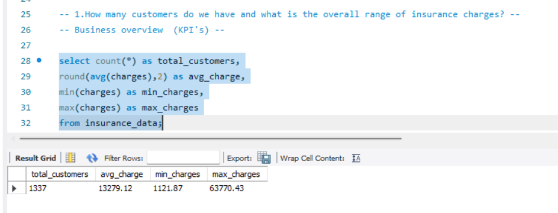
Result:
- Total customers: 1,337
- Avg charges: ₹13,279
- Min charges: ₹1,122
- Max charges: ₹63,770
Insight:
Insurance charges vary widely, indicating the presence of low-cost and high-cost customer segments.
Action/Suggestion:
Create risk-based customer segments and focus on monitoring high-cost customers.
Ⅱ. Impact of Smoking on Insurance Charges
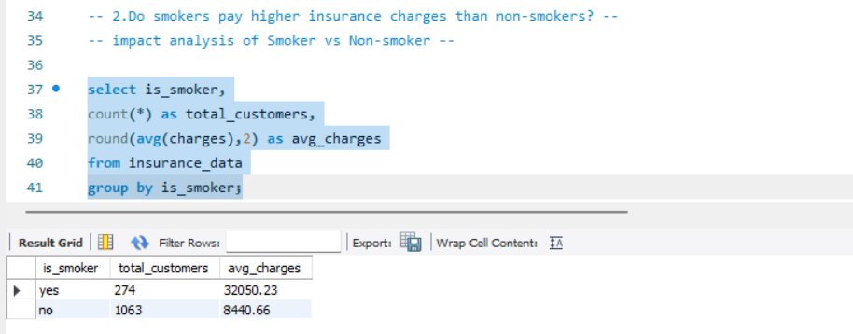
Result:
- Smokers: 274 customers | Avg charges = ₹32,050
- Non-smokers: 1,063 customers | Avg charges = ₹8,441
Insight:
Smokers have almost 4 times higher insurance charges than non-smokers. Smoking is a major cost-driving risk factor.
Action/Suggestion:
Introduce higher premium slabs for smokers and launch preventive health programs to reduce long-term risk.
Ⅲ. Gender-wise Insurance Charges
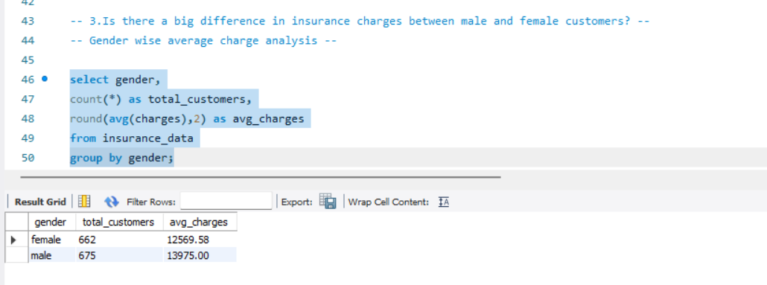
Result:
- Female: 662 customers | Avg charges = ₹12,569
- Male: 675 customers | Avg charges = ₹13,975
Insight:
Male customers have slightly higher average insurance charges than female customers. However, the difference is not very large, which indicates that gender alone is not a strong cost driver.
Action/Suggestion:
Do not design pricing mainly on gender. Instead, focus more on health and lifestyle factors such as smoking status, BMI, and age.
ⅳ. Region-wise Business Performance
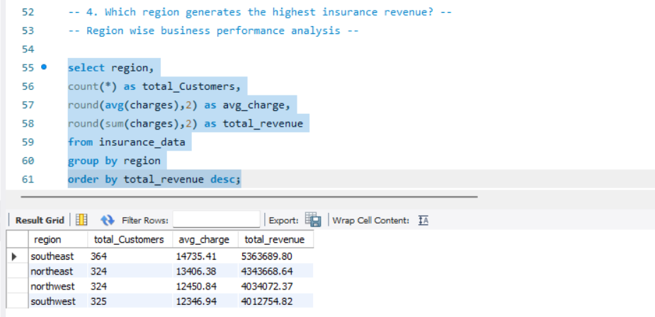
Result:
- Southeast: - 364 customers | Avg ₹14,735 (Highest revenue)
- Northeast: - 324 customers | Avg ₹13,406
- Northwest: - 324 customers | Avg ₹12,451
- Southwest: - 325 customers | Avg ₹12,347 (Lowest revenue)
Insight:
The Southeast region generates the highest insurance revenue and also shows the highest average charges.
Other regions have similar customer counts, but lower average charges and revenue.
Action / Suggestion:
- Focus marketing and premium products in the Southeast region.
- Analyze why other regions have lower charges and design region-specific pricing and health programs.

ⅴ: Impact of Number of Children on Insurance Charges
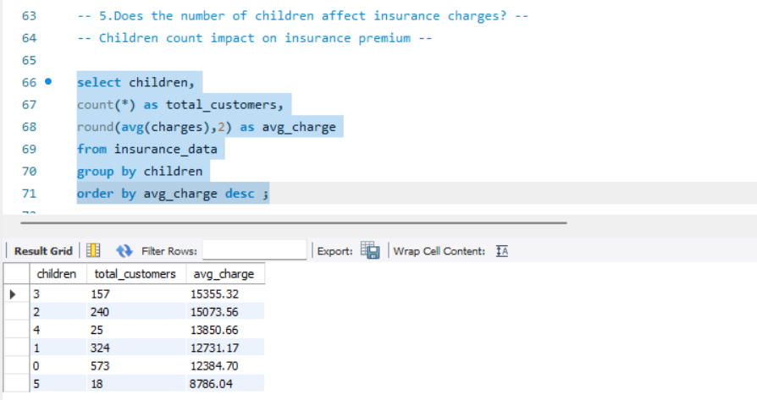
Result:
- 3 children → Avg charges ₹15,355 (highest, sample value)
- 2 children → Avg charges ₹15,074
- 4 children → Avg charges ₹13,851
- 1 child → Avg charges ₹12,731
- 0 children → Avg charges ₹12,385
- 5 children → Avg charges ₹8,786 (lowest, small sample)
Insight:
Customers with 2–3 children show higher average insurance charges. However, the pattern is not strictly linear, which means children count alone is not a strong cost driver, but it slightly influences premium.
Action/Suggestion:
Consider children count as a supporting factor in pricing, but rely more on age, smoking, and BMI for primary risk assessment.

ⅵ. Impact of BMI Category on Insurance Charges
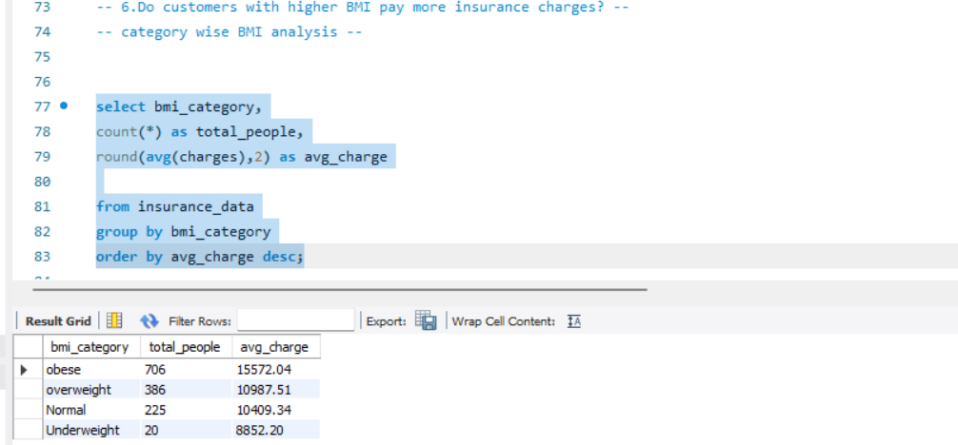
Result:
- Obese → 706 people | Avg charges ₹15,572 (highest)
- Overweight → 386 people | Avg charges ₹10,988
- Normal → 225 people | Avg charges ₹10,409
- Underweight → 20 people | Avg charges ₹8,852 (lowest)
Insight:
Insurance charges increase significantly with higher BMI levels. Obese customers form the largest group and also generate the highest average charges, making BMI a strong health-based cost driver.
Action / Suggestion:
- Include BMI as a key risk factor in premium calculation.
- Launch wellness and weight-management programs to reduce long-term claim costs.

ⅶ. High-Risk vs Low-Risk Customer Analysis
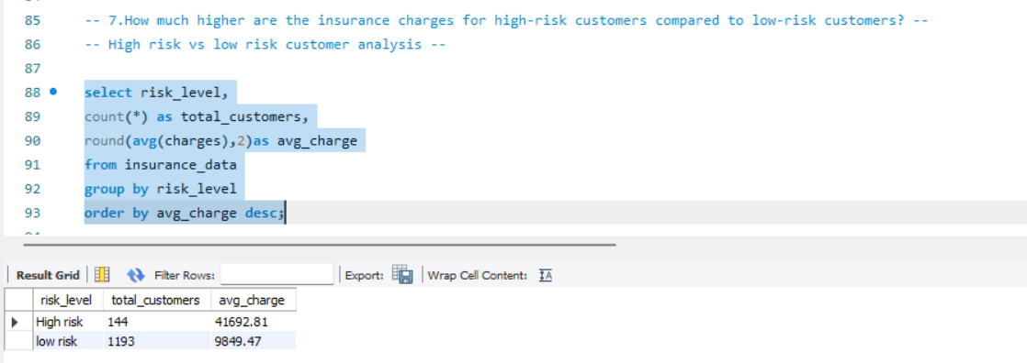
Result:
- High Risk (1): 144 customers | Avg charges ₹41,693
- Low Risk (0): 1,193 customers | Avg charges ₹9,849
Insight:
High-risk customers are very few in number, but their average insurance cost is more than 4 times higher than low-risk customers. This shows that a small high-risk segment contributes disproportionately to total claims.
Action / Suggestion:
- Design separates high-risk insurance plans with higher premiums.
- Invest in early screening and preventive care programs to control high-risk costs.

ⅷ. Impact of Age Group on Insurance Charges
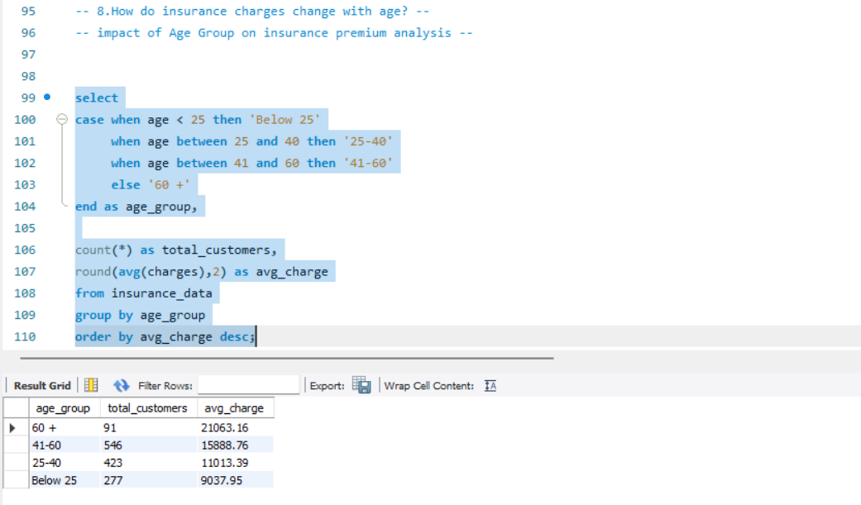
Result:
- 60+ = 91 customers | Avg charges ₹21,063 (highest)
- 41–60 = 546 customers | Avg charges ₹15,889
- 25–40 = 423 customers | Avg charges ₹11,013
- Below 25 = 277 customers | Avg charges ₹9,038 (lowest)
Insight:
Insurance charges increase clearly with age. Customers above 60 have the highest average medical cost, making age a strong and consistent risk factor.
Action / Suggestion:
- Apply age-based premium slabs.
- Provide senior-focused health plans and preventive care programs to manage long-term costs.

ⅸ. Top 10 Highest Paying Customers Pattern
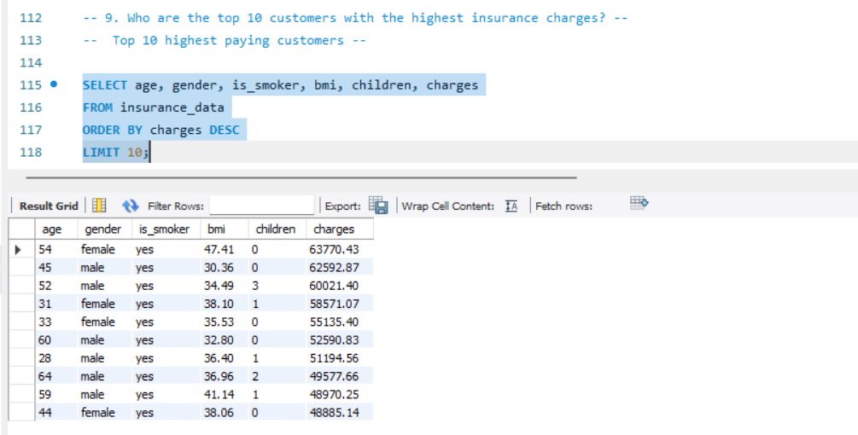
Result:
Top 10 customers have charges between ₹48,885 and ₹63,770. All top 10 customers are smokers, and most of them have high BMI (overweight/obese) and belong to middle-aged or senior groups.
Insight:
The highest-paying customers share common risk characteristics smoking habit, high BMI, and higher age.
This clearly shows that lifestyle and health factors dominate high insurance costs.
Action / Suggestion:
- Build a high-risk customer profile for early identification.
- Design special high-premium plans and health improvement programs for such customers.

ⅹ. Region-wise Top Costly Smokers
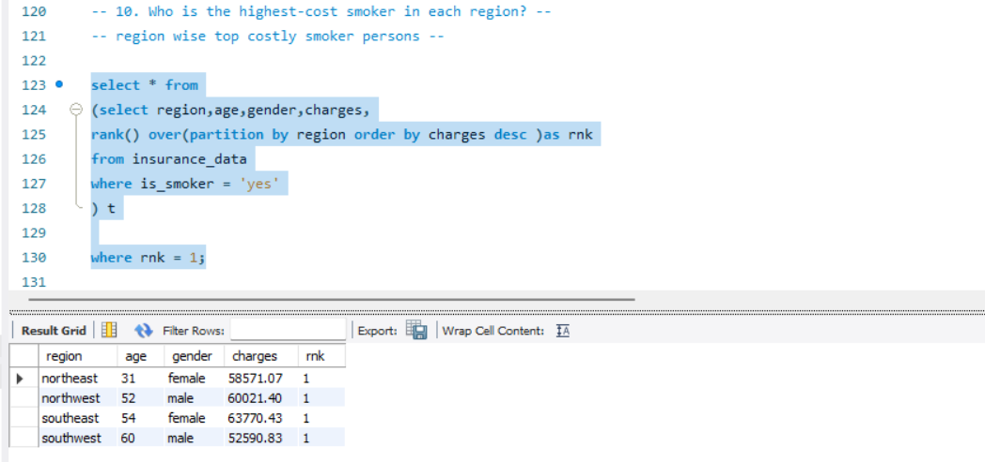
Result:
For each region, the highest-cost smoker is:
- Northeast = ₹58,571
- Northwest = ₹60,021
- Southeast = ₹63,770 (highest overall)
- Southwest = ₹52,591
Insight:
Every region has at least one extremely high-cost smoker, and the Southeast region shows the highest individual medical cost. This indicates that smokers are the most financially risky group across all regions.
Action / Suggestion:
- Identify and continuously monitor region-wise high-risk smokers.
- Design region-specific high-risk insurance plans and targeted preventive health programs.

8.KEY INSIGHTS FROM THE ANALYSIS:
- Smokers have significantly higher insurance charges than non-smokers
- Obese customers show the highest average charges
- Insurance charges increase with age
- Customers with 2–3 children show slightly higher average charges
- High-risk customers form a small percentage but contribute a large portion of total revenue
- Southeast region contributes the highest insurance revenue

9. VISUALIZATION:
A Power BI dashboard was created to present insights clearly:
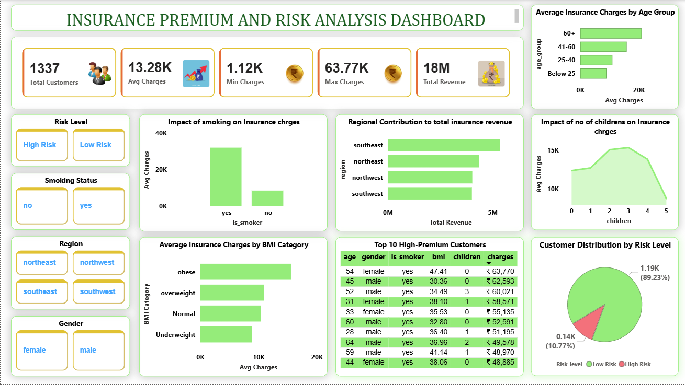
- KPI cards showing total customers, average charges, minimum and maximum charges, and total revenue
- Charts for:
  - Charges by BMI category
  - Impact of smoking on charges
  - Charges by age group
  - Revenue contribution by region
- Interactive slicers for region, smoking status, gender, and risk level
- Table showing Top 10 High-Premium Customers
The dashboard allows dynamic filtering and easy interpretation.

10. BUSINESS RECOMMENDATIONS:
Based on the analysis:
- Introduce higher premiums or special policies for smokers
- Promote preventive health programs for obese and high-risk customers
- Offer discounts or incentives to low-risk customers
- Use risk segmentation to design customized insurance plans
- Focus on high-revenue regions for targeted marketing

11. CONCLUSION:
This project successfully analyzed insurance customer data to identify cost drivers and risk factors.
By combining Python, SQL, and Power BI, meaningful insights were generated that can help insurance companies improve pricing strategies, manage risk, and increase profitability.

